**LAB 7**

**CONFIGURATION WLAN IN PACKET TRACER**

In this lab you will simulate a home/office in which you install a modem from an ISP and where you install your own wireless LAN.

*Note: don’t change the names of the existing devices. And keep the default names for new devices you add.*

1. Open the supplied Packet Tracer PKA file for this lab from Leho.

You will notice that there is already a public network: the Proximus network (a Belgian ISP) was simulated (highly simplified) and works just as it would be in the real world. In the home network, there’s only a single desktop PC, which is not connected to the Internet (yet).

You may know that Proximus does not enter the home via a TV connection, but via a telephone line. What type of connection connector is used?

RJ11 connection

1. Let’s assume you’ve newly subscribed to that ISP and you will now install Internet Access in your home/company. First of all, you need a modem. Find the modems in Packet Tracer (Hint: these devices are needed to connect to a WAN).   
   Notice that there are two types: *DSL* and *Cable* modem. Which one do you need for a Proximus simulation?

A DSL-modem

Use the correct modem and keep the default name (which ends with ‘Modem0’). Use the right cable type to connect it to the “wall” (in our example the cloud). Select the port with the lowest number.

What type of cable should you use for this purpose?

A phone cable

Then connect the desktop to the modem. Which cable type should you use?

Copper straight-through

1. Make sure that your desktop in PT dynamically receives an IPv4 address in the way this happens in a real home network. Thus, set your desktop in PT to use DHCP. This is similar to a previous lab where you changed the IP configuration of a Windows VM, but now this is done in an emulated PC with different looking config windows. What the desktop’s IP address now?

**IP address = 78.55.44.1**

Paste below a screenshot of the IP address configuration of the desktop.

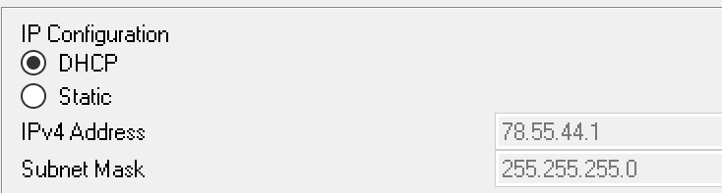

Which device gave your desktop in PT its IP address: the modem, the Proximus router or the Proximus server? How do you know this?

The Proximus Router gives the addresses because that’s where the DHCP-service is running.

1. Check if you can ping to the IP address of the Proximus server (in this network this is 8.8.8.8, but in reality that will of course be a different address).

You can ping

Check if you can surf to [www.google.com](http://www.google.com). Yes

Check if you can surf to [www.google.fr](http://www.google.fr) No

Which websites can you surf to in this fictitious network?

google.be – google.com – www.google.be – www.google.com

Hint: check the DNS settings on the Proximus server (which acts as DNS server here). Again, more on DNS later 😊.

1. However, end devices (PCs or laptops) are rarely connected directly to a modem nowadays. For example, there is wireless router in between (nowadays even integrated with the modem).

Now delete the connection between the desktop and the modem, without deleting the desktop (make sure the desktop is still ‘PC0’). Then add a WRT300N wireless router and connect it with a wired connection to both the modem and desktop. Use the correct interface of the WRT300N to connect it to the modem (that’s its Internet uplink connection).

Which cable type was used for the connection between modem and router?

Copper straight-through cable

What type of cable was used for the connection between desktop and router?

Copper straight-through cable

Take a look at the physical representation of the router, you notice a number of Ethernet ports. How many internal LAN and how many external WAN ports are there?

1 WAN port and 4 Gigabit Ethernet ports

1. Recheck the IP address configuration on your desktop. Because the desktop is now connected to another network (the home network) and therefore also another DHCP server (which is built into the wireless router), you may need to refresh the IP address of your desktop. You do this by first clicking on the radio button *Static* and then back on the *Dynamic* radio button. What is your IP address now?

**IP address = 192.168.0.100**

Paste a screenshot of the IP address configuration of the desktop again below.

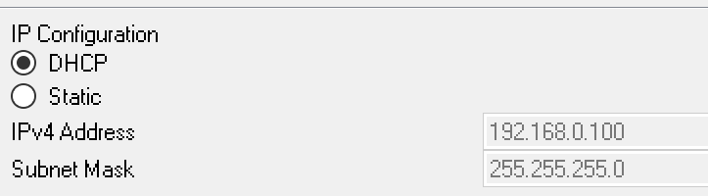

Check if you can ping from your desktop to the Proximus server.

You can ping

Normally you should also be able to surf from your desktop to [www.google.be](http://www.google.be).

(Should this not work: make sure the DNS setting is configured in the GUI of your wireless router! See next steps for information about the GUI.)

1. These kind devices have firmware which you can configure via a web interface, a CLI is not always present. Now let’s have a look at a typical GUI.

You can see the web interface by clicking on the router and using the GUI tab, but this is obviously not realistic as a wireless router doesn’t have built-in screen/keyboard, nor is it possible to attach one to it.

Therefore, to access the web interface, you have to open the browser on your desktop and type in the router’s IP address. How to find that address? The router is the default gateway for the desktop. So, on the desktop in PT (not on the router, that’s cheating), find that IP address and use the desktop’s web browser to surf to it.

**IP address of the router (LAN) = 192.168.0.1**

A user name and password will be requested. Enter ‘admin’ in both fields.

1. In the web interface, locate the “IP address range” of the DHCP server of the wireless router. In other words: you need to find out which IP addresses the router can distribute via DHCP.

Please enter the first and last address below that can be distributed.

**First address =** 192.168.0.100

**Last address =** 192.168.0.149

1. Also at the web interface, no go to the ‘Status’ page. There you’ll see the IP address it has received on its WAN interface. What is it?

**IP address of the router (WAN) = 77.55.44.2**

1. At your home/office, your laptop, tablet etc will probably be wirelessly connected. So add a ‘Wireless Tablet’ end device into your Home Network in PT. It should connect automatically to your wireless router!

What IP did you get? And can you surf the Google website right away? And access the web interface of the router?

**IP address of the tablet =** 192.168.0.101

1. That automatic connection should make you think, there is still one very important part missing: it’s **wireless security**. Certainly not a detail!

It is not recommended to configure the wireless configuration on the router **via** an existing wireless connection. So, use the desktop to surf to the router and go to the Wireless settings page.

Change the **SSID** (= the wireless network its name) to “*mysweethome*” (all lowercase, no spaces) and click on “Save Settings” (scroll all the way done for that button).

1. Now go back to the tablet and configure it to use the same settings to rebuild the wireless connection. Do you still manage to surf?

You can still surf

1. Finally, add a smartphone to your home network (of the type: “Smartphone-PT”) and make it also connect wireless.   
   Note, that’s why they call it a WPA-PSK with PSK standing for ‘PreShared Key’: you need to share that passphrase with all devices. (Which is different for WPA-Enterprise.)
2. The security is of course only complete if we also change the standard router password. Else, anyone can look up the default user and password (admin/admin) and try to login. Now, change the password in the web interface to: “howestrocks”.

Administration – router password

1. Save the exercise as “Lab 07.pka” and upload the file to Leho.